Transformer Architecture Basics
A Transformer is a deep learning architecture that uses self-attention mechanisms instead of recurrence (RNNs) or convolutions (CNNs) to process sequences. It was introduced in the 2017 paper "Attention Is All You Need" and forms the foundation of GPT, BERT, ChatGPT, Copilot, Gemini, DALL·E, Codex, and many other AI systems.
Instead of processing words one after another, a Transformer processes all words simultaneously and learns which words are important to each other using Attention.
Architecture
A Transformer is a neural network architecture designed to process and understand sequential data such as text, code, audio, and images. It was introduced in 2017 and became the foundation of modern AI models like GPT, BERT, ChatGPT, Copilot, and Gemini.
The main goal of a Transformer is to understand the relationship between different words in a sentence, regardless of how far apart those words are. Unlike older models such as Recurrent Neural Networks (RNNs), which process one word at a time, Transformers process all words simultaneously. This makes them much faster and more efficient.
1. Input Embeddings
Converts words into numerical vectors that the model can understand.
2. Positional Encoding
Adds word-order information because Transformers process all words in parallel.
3. Self-Attention
Allows each word to focus on important words in the sentence.
Example:
"The cat drank milk because it was hungry."
The model learns that "it" refers to "cat".
4. Multi-Head Attention
Uses multiple attention layers to capture different relationships such as grammar, meaning, and context simultaneously.
5. Feed Forward Network (FFN)
Processes attention outputs and learns deeper patterns from the data.
6. Add & Layer Normalization
Improves training stability and helps deep networks learn efficiently.
Main Formula
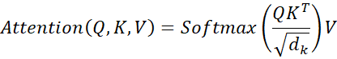
Where:
• Q (Query): What information is needed?
• K (Key): What information is available?
• V (Value): Actual information passed forward.

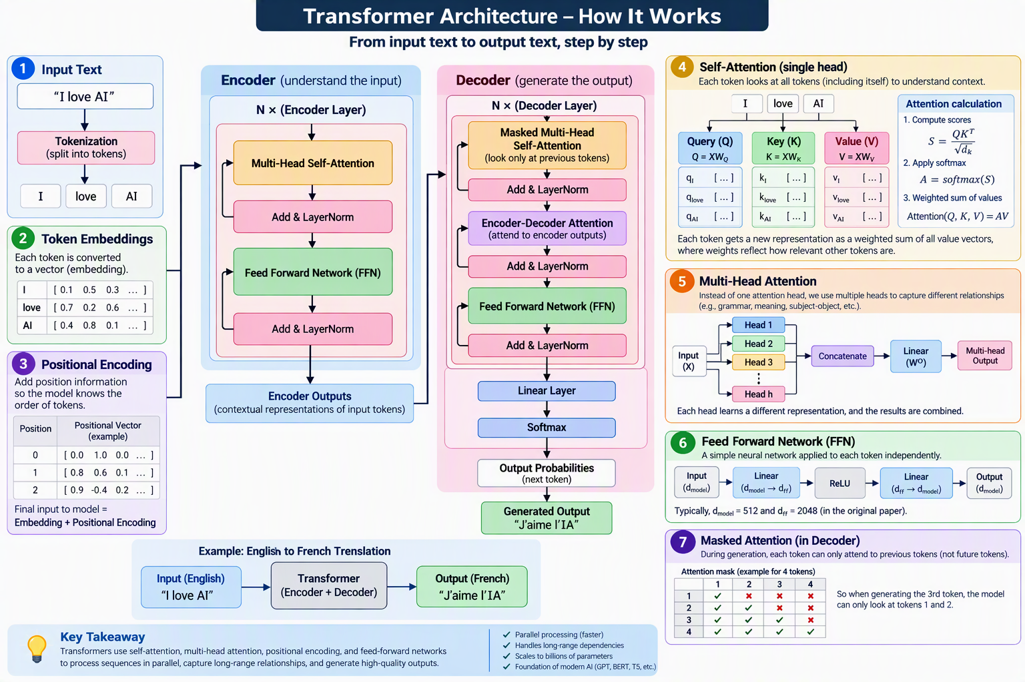

Types of Transformers

1. Encoder-Only Transformers
• Use only the encoder part of the Transformer.
• Good at understanding and analyzing text.
• Used for classification, sentiment analysis, search, and question answering.
Examples: BERT, RoBERTa, ALBERT

2. Decoder-Only Transformers
• Use only the decoder part.
• Generate text one token at a time.
• Mainly used for content generation and conversational AI.
Examples: GPT-3, GPT-4, ChatGPT, Microsoft Copilot

3. Encoder-Decoder Transformers
• Contain both encoder and decoder.
• Encoder understands input, decoder generates output.
• Best for translation, summarization, and text-to-text tasks.
Examples: T5, BART, Original Transformer

4. Vision Transformers (ViT)
• Apply Transformer architecture to images.
• Images are split into patches and treated like tokens.
Applications: Image classification, object detection
Examples: ViT, DeiT

5. Multimodal Transformers
• Process multiple data types together (text, images, audio, video).
• Enable AI systems to understand and generate across modalities.
Examples: GPT-4o, Gemini, DALL·E, Flamingo

6. Speech/Audio Transformers
• Designed for speech recognition and audio generation.
• Handle audio sequences similarly to text tokens.
Examples: Whisper, SpeechT5

Pre-Training Vs Fine-Tuning

Pre-Training
Pretraining is the initial training phase where an AI model learns general knowledge from massive datasets such as books, websites, articles, and code repositories.
It learns language patterns, grammar, facts, reasoning, and relationships between words.
The model is typically trained using tasks like next-word prediction.
Pretraining requires enormous computational resources and large amounts of data.
The output is a foundation model (e.g., GPT, BERT) that can later be adapted through fine-tuning for specific tasks.

Fine-Tuning
Fine-Tuning is the process of adapting a pretrained AI model to a specific task or domain using specialized data.
It helps the model perform better in areas such as healthcare, finance, legal services, or customer support.
Fine-tuning requires much less data and computing power than pretraining.
During this process, the model's parameters are adjusted to learn domain-specific knowledge.
The result is a more accurate and specialized AI model for a particular application.

Aspect | Pretraining | Fine-Tuning
Definition | Initial training of a model on large-scale general data. | Further training of a pretrained model on specific data.
Purpose | To learn general language patterns and knowledge. | To adapt the model for a particular task or domain.
Dataset | Massive datasets (books, websites, articles, code). | Smaller, domain-specific datasets (medical, finance, legal, etc.).
Knowledge Learned | General knowledge and language understanding. | Task-specific or domain-specific expertise.
Training Time | Weeks or months. | Hours or days.
Computational Cost | Very high. | Relatively low.
Resources Required | Thousands of GPUs/TPUs. | Fewer computing resources.
Output | Foundation model (e.g., GPT, BERT). | Specialized model for a specific application.
Example | GPT learning from internet-scale text data. | GPT adapted for medical diagnosis or customer support.
Analogy | School education that teaches general subjects. | Professional specialization such as becoming a doctor or lawyer.

Tokenization
｜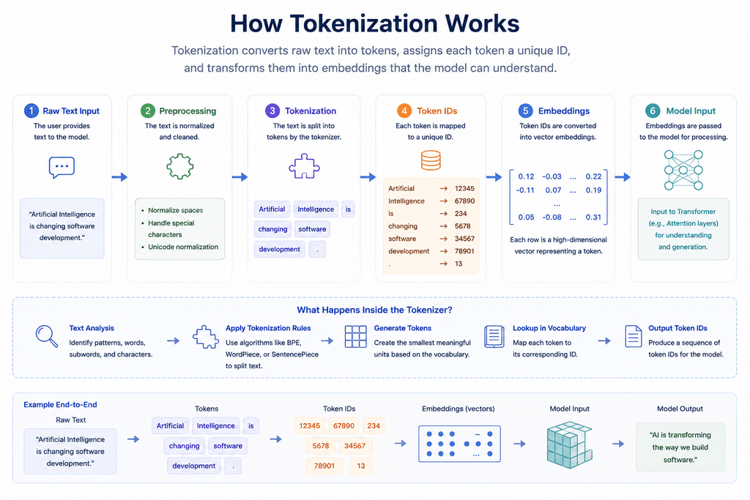
Tokenization is the process of breaking text into smaller units called tokens. These tokens can be words, subwords, characters, or symbols. Each token is converted into a numerical ID that AI models can understand. Tokenization helps reduce complexity and improves processing efficiency. It is the first step in Transformer-based models such as GPT, BERT, and ChatGPT.

Example:
Input:
"I love Artificial Intelligence!"

After Tokenization:
["I", "love", "Artificial", "Intelligence", "!"]

These tokens are then converted into IDs:
"I" → 101
"love" → 205
"Artificial" → 567
"Intelligence" → 890
"!" → 45

The AI model processes these numbers instead of the original text.

Importance:
Pretraining is the first stage in training a Generative AI model, where it learns general knowledge from massive datasets such as books, websites, research articles, and code repositories. During this phase, the model learns language structure, grammar, facts, reasoning patterns, and relationships between words by performing tasks like predicting the next word in a sentence. The training process involves analyzing billions of text examples and continuously adjusting model parameters to improve accuracy. Pretraining requires significant computational resources, large amounts of data, and extensive training time. The result is a foundation model such as GPT or BERT, which can later be fine-tuned for specific tasks or domains.

Types of Tokenization
1. Word Tokenization
It splits the text into individual words.
• Separates text based on spaces
• Each word is treated as one unit
• Does not break words further
2. Sentence Tokenization
This splits the text into individual sentences.
• Breaks text using punctuation (like . ? !)
• Helps in dividing large text into smaller parts
• Useful for summarization and analysis
3. Subword Tokenization
It works by splitting words into smaller meaningful parts.
• Breaks long or complex words into smaller pieces
• Helps handle unknown words
• Balances word and character levels
4. Character Tokenization
It splits text into individual characters instead of words.
• Breaks every word into letters
• Works the same for all languages
• Does not depend on words or vocabulary
5. N-gram Tokenization
This splits text into groups of consecutive words.
• Groups words together instead of splitting them alone
• Helps capture relationships between words
• Can be bigrams (2 words), trigrams (3 words), etc.
6. Byte Pair Encoding (BPE)
Byte Pair Encoding is a subword tokenization technique that splits words into frequently occurring character sequences.
• Merges the most frequent pairs of characters or subwords
• Reduces vocabulary size while preserving meaning
• Widely used in modern NLP models

Embeddings

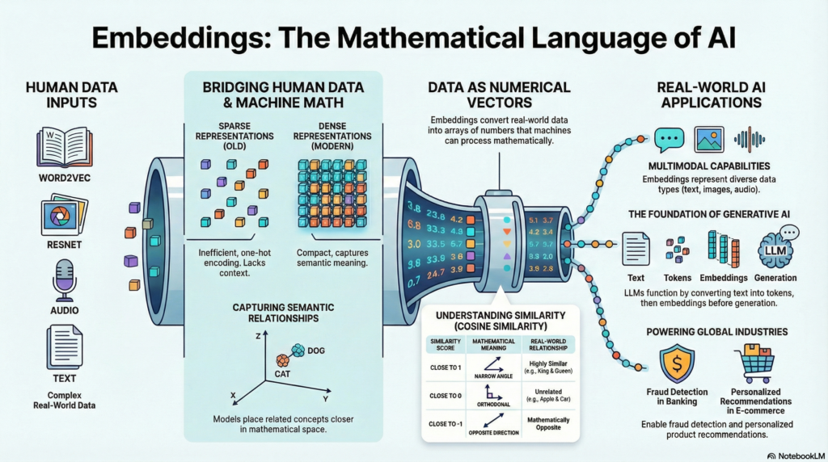

Embeddings are continuous vector representations of discrete data. They serve as a bridge between the raw data and the machine learning models by converting categorical or text data into numerical form that models can process efficiently. The goal of embeddings is to capture the semantic meaning and relationships within the data in a way that similar items are closer together in the embedding space.
Embeddings are crucial because they enable models to handle and learn from high-dimensional data efficiently. They reduce computational complexity and enhance the ability to generalize from the data. For instance, in NLP, word embeddings capture the semantic relationships between words, allowing models to understand context and meaning better.
Types of Embeddings
1. Word Embeddings
Word embeddings are used to represent words in a continuous vector space. Popular techniques include Word2Vec, GloVe, and FastText. These methods learn embeddings based on the context in which words appear, capturing semantic similarities between words.
Example
In Word2Vec, the words "king" and "queen" might have similar vectors because they share similar contexts, whereas "king" and "apple" would have different vectors due to their different contexts.
2. Sentence Embeddings
Sentence embeddings represent entire sentences as vectors. Methods like Universal Sentence Encoder and BERT (Bidirectional Encoder Representations from Transformers) create embeddings that capture the meaning of sentences, considering the order and context of words.
Example
BERT can generate embeddings for sentences, allowing models to perform tasks like sentiment analysis, where understanding the full context of a sentence is crucial.
3. Image Embeddings
In computer vision, image embeddings are generated to represent images in a lower-dimensional space. Convolutional Neural Networks (CNNs) often extract these embeddings from the final layers of the network, which can then be used for tasks like image classification, object detection, and image similarity.
Example
A CNN might produce a 256-dimensional embedding for an image of a cat, which can then be compared to other embeddings to find similar images or classify the image as a cat.
4. Graph Embeddings
Graph embeddings represent nodes in a graph in a continuous vector space, preserving the graph's structure and properties. Techniques like Node2Vec and Graph Convolutional Networks (GCNs) are commonly used to generate these embeddings.
Example
In a social network graph, graph embeddings can help identify similar users based on their connections and interactions.
5. Audio Embeddings
Audio embeddings convert audio signals into a lower-dimensional space, capturing essential features such as phonetic content, speaker characteristics, or emotional tone. These embeddings are commonly used in tasks like speech recognition, speaker identification, and emotion detection.
Example
Mel-frequency cepstral coefficients (MFCCs) are commonly used features for audio embeddings. More advanced techniques involve using pre-trained models like VGGish, which is based on the VGG architecture but adapted for audio data.

